These are the step-by-step instructions for pulling chat transcripts from Genesys for auditing the AI Benefits chat for BSC members.

Genesys login: https://apps.usw2.pure.cloud
Note: To get access to Genesys to view these, create an SMP ticket and ask for the “Designated” Contact Center group.

To search for a particular member’s transcript, here are the steps:

- Navigate to Analytics workspace via the search bar at the top or the left nav:
  - 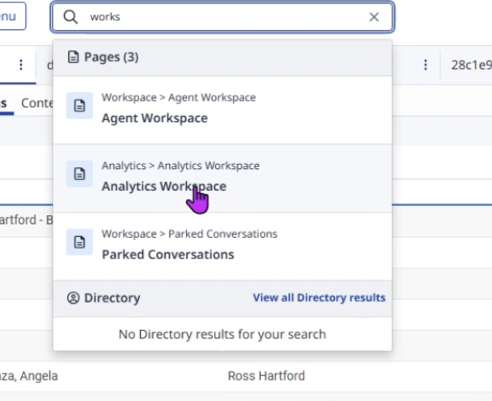
- On the left nav, open the Interactions tab.
  - 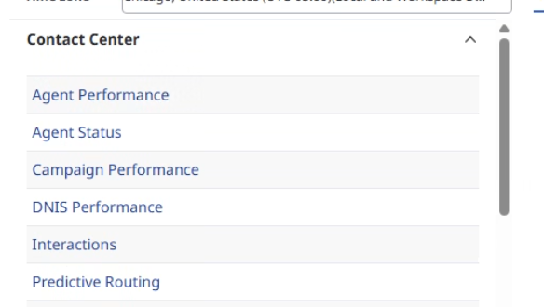
- Click on the filter button on the top right
  - 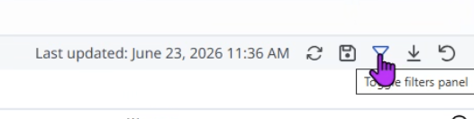
- Click on the message icon in the Media type interaction. Do not use the chat icon, as nothing will populate.
  - 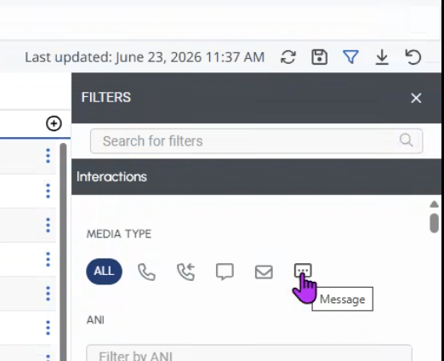
  - In Message Type, uncheck SMS
    - 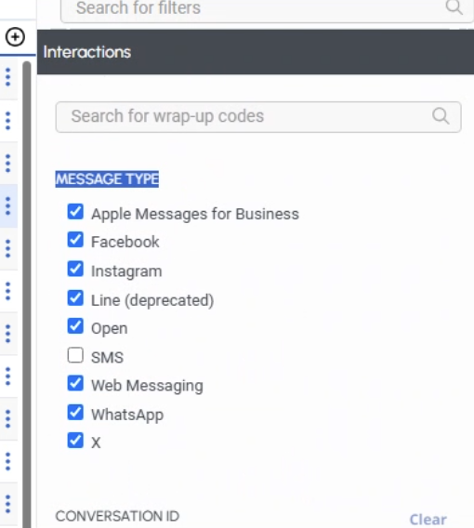
- Close filter tab- you will now just see chats/messages in the list view
- Click on the download button in the top right to export a file
  - 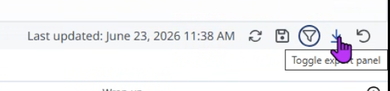
  - Enter the email address for the file recipient(s)
  - In the format section, check both options: Include all native columns and include custom attribute. Click export.
    - 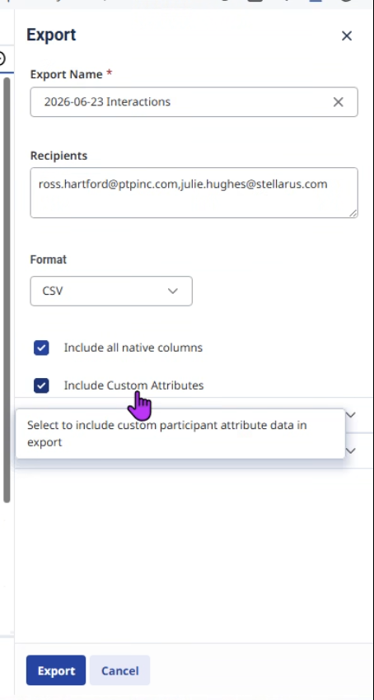
- To retrieve the file, there are two methods:
  - Check your email for the exported file with the chat list
  - Open the Inbox tab at the top, and then the Export button in the top right. Note: This can take a few minutes for either option to see the file.
  - 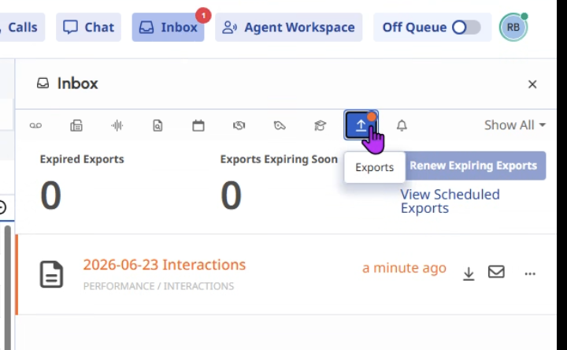
    - If using the inbox, once the file is listed, click on the download arrow in the file to open it. Save the file.
- In the file, scroll over to the far right, and find “Participant Attributes.” This will include a member’s Subscriber ID, Group ID, name, email address, etc. in this column.
  - Note: the screenshot below is a test, so not populated.
  - 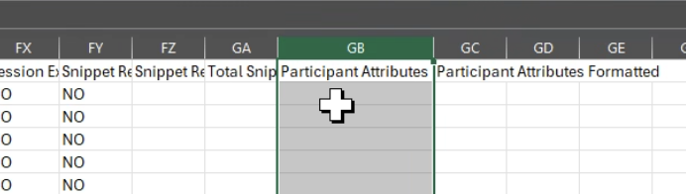
- Search for the SubID to find the member you’re looking for. (Subscriber ID = Member ID in this context.) Copy the Conversation ID for that member.
  - 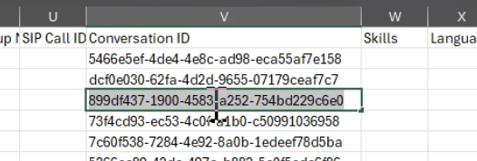
- Go back to filter, and type “Conversation” to bring up the Conversation ID field, and paste the desired Conversation ID. Click to select it.
  - 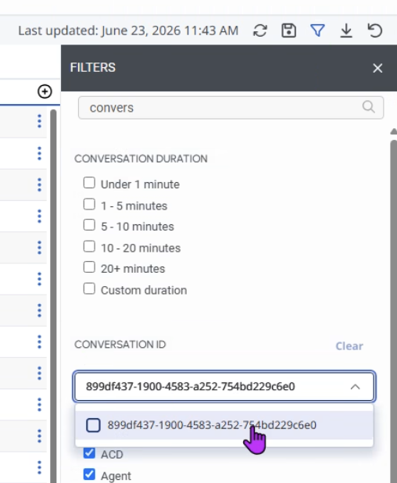
- The conversation should be displayed in the pane to the left.
  - 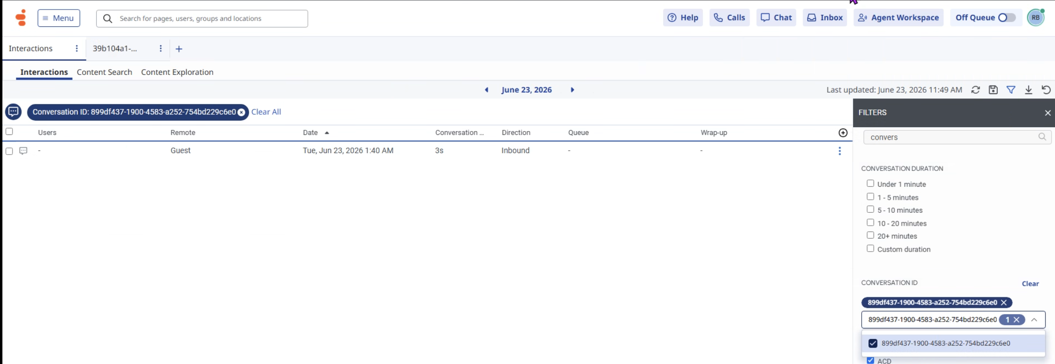
  - Click on the conversation, and it will show the transcript under theBot/Flow section of the Transcript tab.
    - 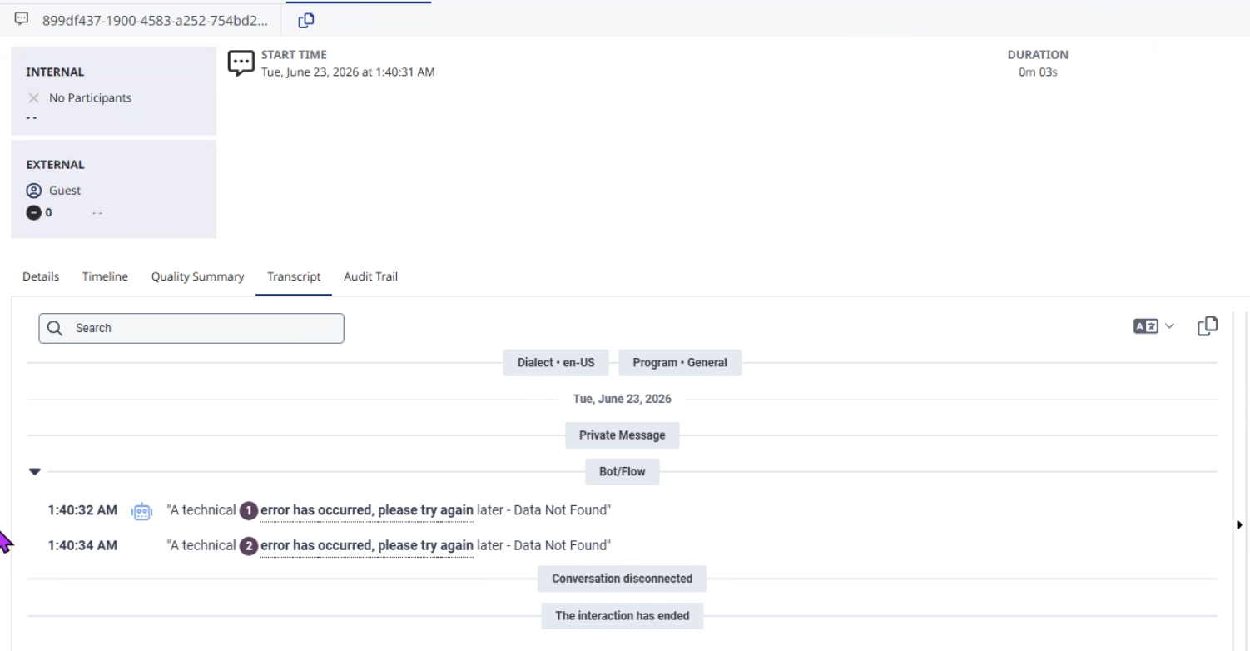

To simply spot check transcripts, skip the steps above about downloading the file and finding the Subscriber ID.

